**Software Verification and Validation Plan**

IEEE 1012 - 2004

Project: Java Air

Prepared by: Matthew D Moscatel and Xu Wu

Team: Avian Limited

Contents

1. Purpose 3

2. Referenced documents 3

3. Definitions 4

4. V&V overview 4

4.1 Organization* 5

4.2 Master schedule 5

4.3 Software integrity level scheme 6

4.4 Resource summary 6

4.5 Responsibilities 6

4.6 Tools, techniques, and methodologies 6

5. V&V processes 6

5.1 Management of V&V 7

5.2 Acquisition V&V 7

5.3 Development V&V 7

5.4 Operation V&V 7

5.5 Maintenance V&V 8

6. V&V reporting requirements 8

6.1 Reporting 8

6.2 Administrative 8

6.3 Documentation 8

7. V&V administrative requirements 8

7.1 Anomaly reporting and resolution 8

7.2 Task iteration policy 8

7.3 Deviation policy 8

7.4 Standards, practices, and conventions 9

8. V&V documentation requirements 9

# 

|  |  |  |  |
| --- | --- | --- | --- |
| **Version** | **Date** | **Author** | **Description** |
| 1 | 10/5/2016 | M. Moscatel | Document Creation |

# 1. Purpose

This document describes the means by which the Java Air project will produce and maintain a high quality product. This maintenance will be performed through the verification and validation of the input/output expected management as well as the verification of source code in real time. The Java Air project is Java-based software that simulates the management software of an airline company. The scope of this document comprises the artifacts of all releases.

# 2. Referenced documents

Decide on referenced documents as needed

# 3. Definitions

# CI = Configuration Item

# CMMI = Capability Maturity Model Integration

# IEEE = Institute of Electrical and Electronics Engineers

# QA = Quality Assurance

# SEI = Software Engineering Institute

# SCMP = Software Configuration Management Plan

# SPMP = Software Project Management Plan (this document)

# SRS = Software Requirements Specification

# SDD = Software Design Document

# SQAP = Software Quality Assurance Plan

# SVVP = Software Verification and Validation Plan

# STP = Software Test Plan

# UD = User Documentation

# WBS = Work Breakdown Structure

# U/PD = User/Product Director

# PM = Project Manager

# RE = Requirement Engineer

# SA = Software Architect

# IE = Integration Engineer

# TE = Testing Engineer

# CD = Code Developer

# PNW = Purdue University Northwest

# 4. V&V overview

The V & V approach as described in IEEE 1012-2004 will be used for conducting project V & V activities. The activities will be planned and scheduled per the project schedule, the SRS, the PQP, and the availability of Cis.

## 4.1 Organization

The responsibilities of the participants in the project are show below.

|  |  |  |  |  |  |
| --- | --- | --- | --- | --- | --- |
| ***Members*** | *Requirement Engineer* | *Integration Engineer* | *Project Manager* | *Testing Engineer* | *Software Engineer* |
| *Liaison Responsibility* | U/PD, PM | U/PD, PM | U/PD, All Members | PM | PM, RE |
| *Document Responsibility* | SRS | SCMP & UD | SPMP | SQAP, SVVP & STP | SDD |

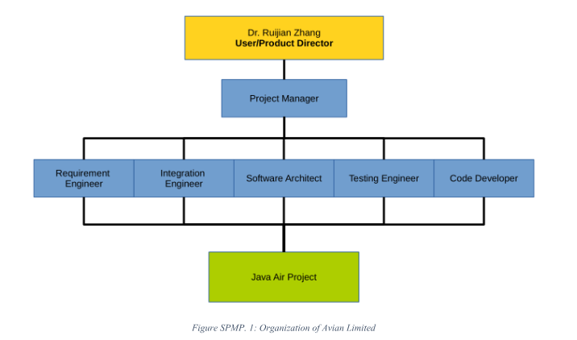

Responsibilities between Xu and Matt will be determined as the test plan is developed further.

## 4.2 Master schedule

The current project schedule is needed in order to prepare testing schedules.

The SVVP and SQAP are due on 10/5/2016.

## 4.3 Software integrity level scheme

## IEEE 10 12-2004, Section 4, provides guidance on selection of criticality levels for software based on its intended use and application. Criticality levels are established by a subjective evaluation of attributes. IEEE 1012 uses Integrity Levels to quantify criticality. The assigned Software Integrity Levels may vary as the software evolves. However, the software and hardware developed for client interaction related portions of this project will be used in a functional critical application and shall be classified as Software Integrity Level 4 (Criticality-High).

## The project documents listed below identify the types of design outputs at the system level and will be assigned a Software Integrity Level 4 rating:

## 1) Project Plans, Software V&V Plan.

## 2) Project Specifications/Reports

## a. Software Requirements Specification (SRS)

## b. Software Design Description (SDD)

## c. Validation Test Specification

## d. Verification Test Specification

## e. V&V Activity Summary Reports

## 3) Database Design Integration Drawings.

## 5) Verification and Validation Test Produces, Test Reports, Final V&V Report.

## 4.4 Resource summary

Written in Java, using SQLite, android and apple app?, windows browser etc? Stress testing software needs to be determined. Can we apply monte carlo logic for functions if needed?

## 4.5 Responsibilities

As stated in organization, the responsibilities between Xu and Matt will be decided as the test plan is developed further

## 4.6 Tools, techniques, and methodologies

As states in Resource summary, current stress testing decision need to me made. For now, we are using Microsoft Word for document creation, PDF writer for PDF conversion, and google drive for document sharing

# 5. V&V processes

The following explains the correlation of the Invensys Java air life cycle to IEEE 1012-2004 life cycle processes and activities.

|  |  |
| --- | --- |
| IEEE 1012 V&V Lifecycle Process | Java Air Lifecycle Process |
| Management | Performed throughout lifecycle |
| Acquisition | Requirement Engineer Acquisition |
| Development | Development |
| *Concept | SRS document interpretation |
| *Requirements | SRS document interpretation |
| *Design | Architect Design |
| *Implementation | Integration |
| *Test | QA Testing |
| Operation | Deliver to Customer |
| Maintenance | Real time maintenance only, program won't be used after course is concluded |

## 5.1 Management of V&V

The Management process is applicable to all phases the Project. Java Air management shall meet the task performance requirements for management of V&V as stated in IEEE 1012-2004.

## 5.2 Acquisition V&V

The Requirement engineers are responsable for acquiring all relevant information from the client. These requirements will be documented in the SRS.

## 5.3 Development V&V

The Architect and Integration engineer will be responsible for developing and integrating the source code, GUI, and compiled code.

## 5.4 Operation V&V

This phase covers the operation of the software product and operational support to users after installation normal commissioning. It addresses operational testing, system

operations, and user support with respect to the operating procedures. It is the responsibility of the Testing engineers to test the operational integrity of the software.

## 5.5 Maintenance V&V

We will not be performing Maintenance outside of real time when needed. This software is not meant for commercial use after the conclusion of the course.

# 6. V&V reporting requirements

## V&V reporting shall occur throughout the entire life cycle and include the following reporting mechanisms.

## 6.1 Reporting

Summary reports are required for the following phases:

* Requirements Phase
* Design Phase
* Implementation Phase
* Test Phase

## 6.2 Administrative

## 6.3 Documentation

Documentation for the six requirements may not be enough. Need to collect further information regarding requirements.

# 7. V&V administrative requirements

## 7.1 Anomaly reporting and resolution

Anomaly reporting will be defined in PPM 10.0, Nonconformance and Corrective Action.

## 7.2 Task iteration policy

All task interactions will be logged with correct nomenclature. Reference number for nomenclature standard?

## 7.3 Deviation policy

Deviations from any standard will be corrected by the responsible party.

## 7.4 Standards, practices, and conventions

Do we need to meet confidentiality standards, personal privacy standards, payment security standards, etc?

# 8. V&V documentation requirements

The test plan still needs to be developed so more information will follow.

The Verification process will include documenting what code and documentations have been reviewed and on which date. Each nonconformance and anomalies will be documented as corrective actions and the closing of said corrective action would be documented for completion. Each nonconformance will be given a unique nonconformance number for tracking purposes. Nonconformance numbers will be classified based on which part of the development stage it was found, what are the effects of the correction, and responsible party.

Validation testing will consist of input and output QA testing. Every test performed will be given a unique test number. If a test fails, said test will be associated with a unique nonconformance number.

NOTE*

Reference standards and definitions need to be updated. The current data is either missing entirely or incomplete. This will be updated as standard decisions are made